Internet of Things(IoT) based Automatic Pet

Feeder

Manasi Patil(80), Harshal Sonawane(89), Shashank Patil(81), Uma Thakur(91), Chaitanya Patil(79), Bhavin Patil(78)

***Abstract—*** **The Internet of Things (IoT) generates an extensive network of devices that frequently exchange data as the world becomes increasingly networked. Automation can be done independently by machines, but it can be augmented with monitoring and regulating capabilities with the help of IoT. While this interconnectedness occurs on a worldwide scale in businesses and organizations, it also occurs in individuals' homes. Consumers are increasingly interested in smart home devices and gadgets, which allow them to connect all of their devices for convenience and ease, comfort, energy efficiency, and, most importantly, personalization, which is one of the project's main goals. With the help of automation and IoT, the user's experience becomes even more individualized.**

**Not everyone is a pet specialist, maintaining your pet's food can be difficult and time-consuming. Overeating and obesity are two of the most common health problems in pets. They are usually content with whatever is handed to them, especially when they are younger. Many adult pets are fed in an incorrect manner, which may result in a shorter lifetime. Another issue with feeding pets is that owners may not always be there. Being engaged with personal stuff while still caring for a starved young fellow at home is often a source of stress for owners. This paper presents an IoT enabled pet feeder system as the pet keeping is a time-consuming responsibility and we want to provide convenience to owners by helping them feed their pets easily and smartly.**

**Keywords—*Pet Feeder, Internet of Things, Automation, Blynk, Servo motor, NodeMCU ESP8266***

# INTRODUCTION

This document describes The Internet of Things (IoT) based Automatic Pet Feeder.

Automation has recently been a technological revolution in demand on an industrial scale as well as in our daily life gadgets. Customers are more fascinated by automatic devices than anything else, and this is for the purpose of ease of use and time savings. Companies are working to meet these demands, and the automation industry is becoming better and much more developed each day. Automation is a means of automatically controlling and operating procedures using electronics and software that may be programmed and applied using machine learning technology. Automation is not a new concept; the first ATM machine was introduced in the 1960s, and with the help of such technology, the process became much easier, faster, and more convenient for the consumer. [1]

The majority of pet owners nowadays would like to enjoy their pets' company; some pet owners have the time and patience to feed their pets, while others do not. This is where automation and the Internet of Things (IoT) come in helpful to create a system that can satisfy the pet owner while causing no harm to the pets.

The automatic pet feeder can provide a fully personalization where the pet owner can program the feeding schedule, where the food can be dispensed at set times and in specific quantities, where previous research will be taken into account, where it will open up more opportunities to understand and learn from previous experiences, and the system can be upgraded with as many functions as possible

to satisfy the pet owner.[3]

Not every pet owner has the time to feed their animals as per their diet plan. In fact, most pet owners who work or study until late in the evening are not punctual in feeding their pets. In general, people underestimate the severity of this problem, so pet owners often solve the problem by overfilling the food dish with a large quantity of food. Not only busy pet owners do this, but also pet owners who are impatient in putting food for their pets three times a day and doing this. Pets, of course, need special attention and care. Pet care, however, becomes extremely difficult due to the hectic schedule.

In the proposed system, the automatic pet feeder, we are able to feed the pet automatically at the set time by the owner using Blynk application, servo motor and the ESP8266.

# LITERATURE SURVEY

The goal of this literature review is to provide an overview of current knowledge in the fields of sensors, controllers, and automatic animal feed dispensers. A number of scholarly articles and conference proceedings were read and analyzed for any relevant material on the topic at hand as part of the comprehensive research. The use of technology to remotely control a sequence of processes is becoming increasingly common in today's society. It is possible to entirely automate and remove the feeding process from any personal physical necessity using MCUs and a well-built and designed pet feeder system, resulting in significant labor cost savings on a wider scale.

Current automatic pet feeders on the market meet some of our design goals, but they are extremely expensive. The Petwant SmartFeeder by GemTune has a smartphone app that allows for scheduled feeding and system configuration. When the pet is close by and it is time to feed, the Automatic Pet Feeder from Wireless Whiskers uses RFID to release food for the pet.[5]

In 2016, the paper "Design of Pet Feeder Using Web Server as Internet of Things Application" was published in the 2nd international conference on Electrical Engineering (IconIEE). This system was created to replace manual feeding with automated feeding. The primary flaw we discovered with this device was that it relied on a web application to monitor and feed pets automatically. Because this web application is not a good alternative, our device includes an Blynk App that can be used from anywhere.[6]

"The Study and Application of the IoT in Pet Systems" This paper was published online in January 2013. The smart pet door was the first gadget in the pet monitor system, and it can assist the pet owner in controlling their pet's behavior. The smart pet feeder is the other device. The pet owner might schedule the pet eating bowl time remotely with the help of the technology. They have provided a pet door as a downside, which may not be the best solution, but our equipment has a

camera that is used for genuine monitoring.[7]

In 2017, the work "Automatic Pet Monitoring and Feeding System Using IoT" was published in the IJCR. This was a pet feeding system that served the same purpose as ours in terms of feeding the pet. However, the designer attempted to offer a new feature with this device, which was a pet collar that was used to track the whereabouts of the pet. The primary downside is that because it was designed for pets that are normally kept at home, having a tracker makes little sense.

[8]

"Automatic Pet Feeder Using Arduino" was published in the International Journal of Innovative Research in Science and Technology (IJIRSET) on March 3rd, 2018. As the name implies, this was a system designed to automatically feed pets as a substitute to manual feeding. But the primary issue was that it was built on Arduino, which isn't necessarily a bad thing, but we prefer the NodeMCU. [9]

Moving away from traditional general feeders, more macro components, such as the mechanism for dispensing food from the container, must be examined.[10] This mechanism must be able to dispense food precisely while also being mechanically sound enough to prevent jamming and binding all along the food's path. In real-world circumstances, several dispensing systems were discovered. The paddle-based dispenser found in cereal dispensers is the first mechanism. These are straightforward, but they frequently bind and lack precise control. The sliding door dispenser is the second mechanism. This is a simple open and close sliding door that would rarely bind, but portions would be quite difficult to handle.

# PROPOSED METHODOLOGY

In the proposed system, we have used the Blynk app, Arduino, servo motor, NodeMCU ESP8266. This system can be used to feed the the pet just by clicking a button on the Blynk application also the remainder can be set so that the pet owner will receive the mail as pop up as well about time to

feed the pet

Blynk Application

Blynk is a comprehensive software suite for developing, deploying, and remotely administering connected devices at any scale, including small IoT initiatives to millions of commercially available linked devices. It may be used to connect hardware to the cloud and create no-code iOS, Android, and web apps to analyze real-time and statistical data from devices, manage them remotely from anywhere on the planet, receive important notifications, and more. The Blynk mobile application will be used to control the servo motor that is attached to the pet feeding setup in this project.

Arduino IDE

The Arduino IDE is an open-source program for writing and uploading code to controller boards. In the Arduino IDE sketching refers to the process of writing a programme or code To upload the sketch written in the Arduino IDE software, we must link the controller boards to the IDE. The '.ino' extension is used to save the sketch.

In this project we are going to use the Arduino IDE on Windows OS. It will connect NodeMCU with the Blynk Application for automating the pet feeding process and to set the time of feeding

NodeMCU ESP8266

NodeMCU is an open-source platform based on the ESP8266 that allows devices to be connected and data to be

|  |
| --- |
| transferred using the Wi-Fi protocol. We are using a NodeMCU ESP8266 as the main controller in this project to control the servo motor    Servo Motor  Servo motors, or "servos," are electronic devices having rotary or linear actuators that precisely rotate and push elements of a machine. Servos are primarily used to control angular or linear position, velocity, and acceleration. In this project we are using the servo motor to operate the pet feeder. |

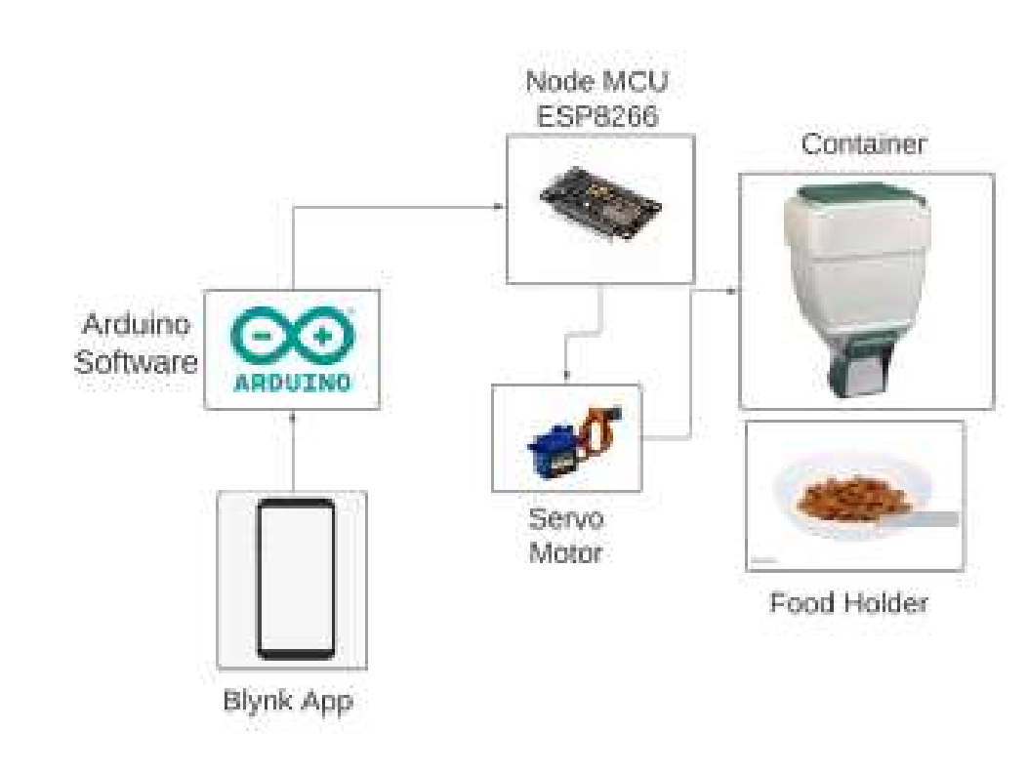

Fig 1: Block Diagram of pet feeder

As shown in the figure 1, we will be using the Blynk application to operate the pet feeder. We have created the template on the Blynk application and then added the device which will be connected to the NodeMCU. Arduino IDE is used to code to begin the Blynk Application and code to drive the motor. Program will be uploaded into the NodeMCU which later on can be provided with the current supply to work without any connectivity with the laptop. Servo motor will be implanted on the container that holds the food. Servo motor is basically used to operate the lid of the container that dispenses the food in the food container. Servo motor will be driven by the NodeMCU with 3.3V supply. Using the Blynk application, pet owners can set the time to feed the dog. Pet owners can set time for 3-4 times of the day. On the set time pet owner will receive the email and pop up about the time to feed the pet. So that pet owners can feed their pet no matter where they are on the time.

Fig 2: Circuit connectivity of NodeMCU ESP8266 with servo motor

Connections are as easy as it seems in figure 2. We have to connect the servo motor with the NodeMCU. Red wire of the servo motor which is the Vcc connects it to the 3.3V pin of the NodeMCU. Brown wire of the servo motor which is the GND connects it to the GND of the NodeMCU. Yellow wire which is the signal wire of the servo motor connect it to the D3 pin of NodeMCU

# RESULTS

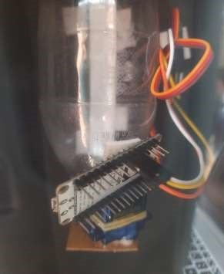

Fig 3: Pet Feeder Assembly

Fig 6: On-Off button

Fig 4: Blynk template

Fig 5: Owner receiving Email

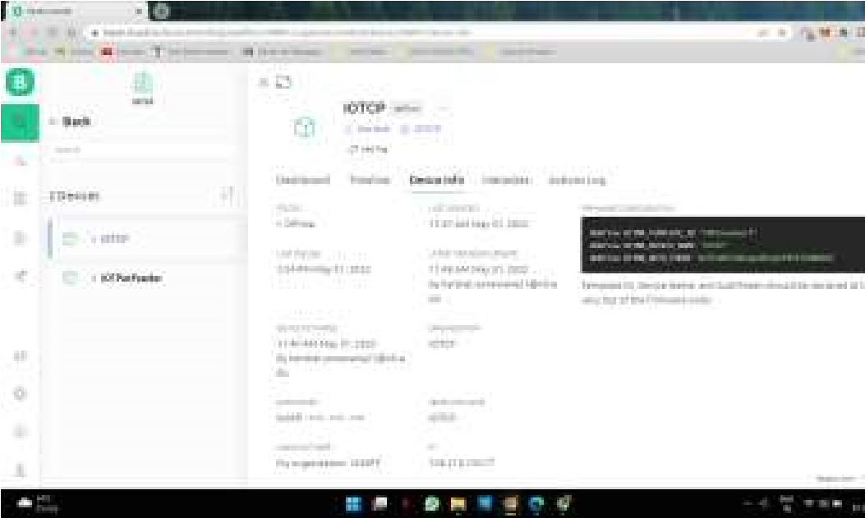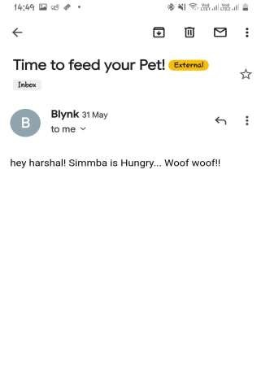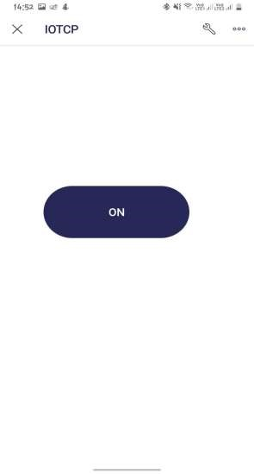

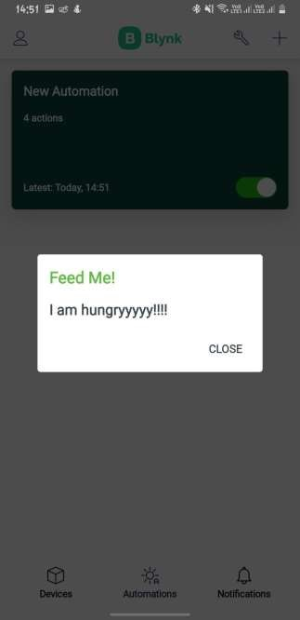

Fig 7: Owner receives pop up message

Code is uploaded on the NodeMCU. Upon configuring the Blynk application , a template was created as shown in figure 4. The Blynk template was registered. Pet feeder is connected to the internet. When a button is clicked on the Blynk app the food gets dispensed from the container. Food will be dispensed as long as we hold the button. Apart from that the pet owner can set the reminder in the Blynk app to get us the pop up on the app at that particular time reminding him to feed the dog(figure-7). Also the pet owners receive an email about the same(figure-5).

# CONCLUSIONS AND FUTURE WORK

Most of the pet owners are not having enough time to feed their pet at the right time each day due to several reasons. The proposed system is to overcome this problem. Using this system one can feed their pet by using Blynk Mobile Application or web dashboard at any time and from anywhere. Just setting the time you can feed your pet. Pet Feeder is simple, efficient, and economic.

Future work in this project can be done as the system can automatically detect when the pet is hungry and how much amount of food to be dispensed according to the weight of the pet. This can be achieved with the help of the Internet of Things.

# REFERENCES

1. Raed Abdulla. ‘IOT based Pet Feeder’, March - April 2020, Volume 83, ISSN: 0193-4120
2. Priya Mondal, Dr. Swapnili Karmore, Rajnandnee Parnami, “Design and development of IoT based Smart Pet Feeder”, May 2020, Volume 9, pp. 6081-6083
3. Zhuokai Zhao, Ziyun He, Fan Ling. “Automatic Pet Feeder

Project, February”. 2016

1. Ahmed Mandy, Hassan Qazweeni, Mohammed Noureddine, Talal Al-Radhwan, Mohammed El-Abd, “Smart Pet House”, 2020
2. S. Subaashri, et al., “Automatic Pet Monitoring and Feeding System Using IoT”, Volume.10 No.14, pp 253-258, 2017
3. Soumallya Koley, Sneha Srimani, Debanjana Nandy, Pratik Pal, Samriddha Biswas, Dr. Indranath Sarkar, “Smart Pet Feeder”. 2021
4. Matt Smith, Chris Ranc, Shabab Siddiq, “Automated Cat feeder”2018
5. San Luis Obispo, “Design And Build Of An Automated Animal Feed Dispenser”, 2016
6. Chung-Ming Own, Haw-Yun Shin, Chen-Ya Teng, “The Study and Application of the IoT in Pet Systems” 2013
7. Andi Adriansyah, Muchd Wibowo, Eko Ihsanto, “Design of Pet Feeder using Web Server as Internet of Things Application”, 2016
8. Mritunjay Tiwari , Sahil Hawal , Nikhil Mhatre, “Automatic Pet Feeder Using Arduino”, Vol. 7, Issue 3, March 2018
9. M. Todica, “Controlling Arduino board with smartphone and Blynk via internet ”, 2016
10. Vaibhav Malav, “Research Paper On Home Automation Using Arduino”, April 2019
11. Abdul Wali Abdul Ali, “A Review on The AC Servo Motor Control Systems”, 2020
12. Joao Mesquita, Diana Guimarãe, Carlos Pereira, Frederico Miguel

Santos, “Assessing the ESP8266 WiFi module for the Internet of Things”,

2018